Banco Federal de Finanças

Marketing Campain Analysis

## presented by

Kyle Tolliver

Jesse Gibbons

Richard Kung

Shane Mecham

Benjamin Hinchman

# Contents

I. Analysis Overview 3

II. Targeted Marketing Campaign Models 3

III. Prior Marketing Campaign Analysis 5

IV. Conclusion and Caveats 7

V. Python Notebooks 7

1. Analysis Overview

We just hired as a junior data scientist for Banco Federal de Finanças in Aveiro, Portugal. They just finished a major telemarketing campaign and management was not happy with the results.

They feel like machine learning could help them create a more targeted campaign. You and your team have been brought in to discuss the situation.

1. Targeted Marketing Campaign Models

The code is supposed to help analysis with clustering but all i really see is there is a trend of repeat customers. Also most who don't subscribe to a term deposit are married. I wanted to add a way to filter categorical data so we can see if there are trends on different weekdays or months but colab seems to have broken when i tried.

As for the decision trees, employment seems to be the most important factor

* Number of employees i mean
* Ignoring that the euribor seems to be most important
* In principle pay attention to the economy

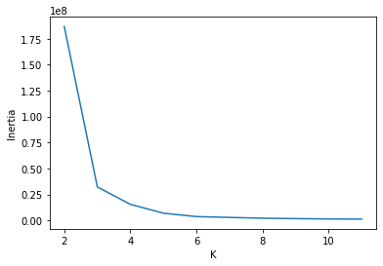

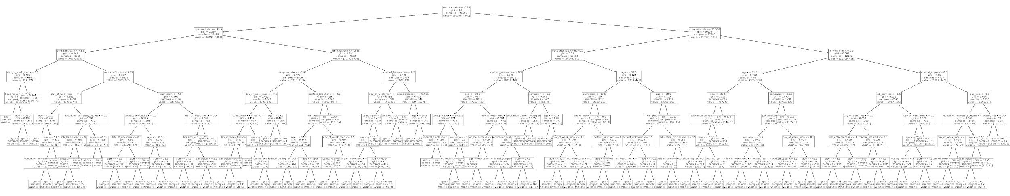

1. Prior Marketing Campaign Analysis

Time when the person was approached.

Day of the Week: Thursday shows a slight uptick in the number of yeses recorded. There would need to be some deeper evaluation as to why these days may be overachieving.

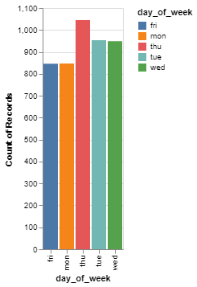

Month: May vastly outperforms the other months, December vastly underperforms compared to the other months, and January and February have no contacts at all.

Vacation days may be skewing the number of yeses in December as many employees might be spending the holidays with their families.

There are no contacts in January and February which means that there would obviously be no yeses.

As for May, in Europe vacations and tourism start gearing up people in the tourism industry might be more likely to make investments as they now that they will make a lot of money during these months. It's also possible people might be setting aside a little money for next year so they can have vacations.

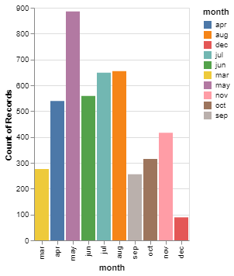

Contact type: Cellular devices vastly outperform regular telephones in the number of yeses. This may be due to the lack of land line phones that are being used anymore. According to this study only 6.5 percent of Americans own a household landline anymore.

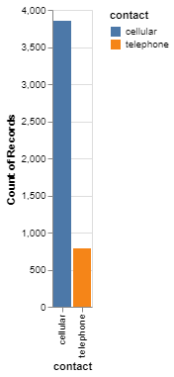

Job: There are three jobs that commonly say yes to a term deposit: Admin; Technicians; and blue collar.

Admin is one of the highest which may be due to most admin jobs paying enough that investing is more viable.

Technicians and Blue Collars are the next two and that may be due to them making money but not enough to have all financial worries taken care of so they are using term deposits to try to get ahead.

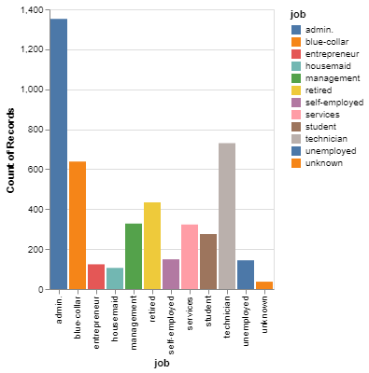

1. Conclusion and Caveats

We were able to work data in many different ways. We made a decision tree using the data to train the machine learning algorithm. We also used the data to do normal data analysis tools. We made graphs to get value counts. We hope this answers your questions. We hope you can get great insights from this report.

1. Python Notebooks

Below are Github Gist links to the notebooks we used during this case study:

<https://colab.research.google.com/gist/kctolli/35d42187c885c90f8286b000cc6bdaae/shane-data-analysis-module-03.ipynb>

<https://colab.research.google.com/gist/kctolli/2c40b951770d3b017e2e24bce78b05c1/jesses-module-03-clustering-tool.ipynb>

<https://colab.research.google.com/gist/kctolli/e6da051e8ea77c6aeb257d1769cfecf5/jesses-module-03-tree-tool.ipynb>